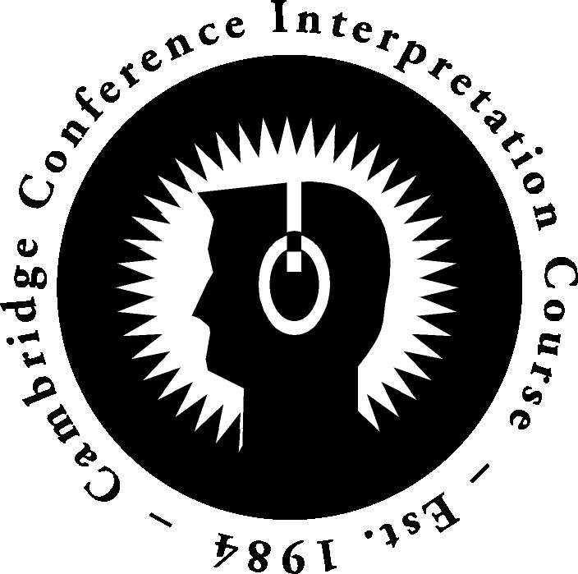
ENROLMENT FORM –

PHOTO

(NB: no enrolment form will be processed without a photograph)

CONFERENCE INTERPRETATION COURSE

Date: . . . . . . . . . . . . . . . . . . . . . . . . . . Date of Birth: . . . . . . . . . . . . . . .

Surname: . . . . . . . . . . . . . . . . . . . . . . . . .First name: . . . . . . . . . . . . . . . . . . . . . . . . . . . M / F

Nationality: . . . . . . . . . . . . . . . . . . . . . .Nationality at birth:. . . . . . . . . . . . . . . . . . . . . . . . . . . . . . . . . .

*Do you need a visa to come to the UK as a tourist? (see https://www.gov.uk/check-uk-visa) . . . . . .

Address: . . . . . . . . . . . . . . . . . . . . . . . . . . . . . . . . . . . . . . . . . . . . . . . . . . . . . . . . . . . . . . . . . . . . . . . . . . .

Tel.: . . . . . . . . . . . . . . . . . . . .Mobile: . . . . . . . . . . . . . . . . . . . . . . E-mail: . . . . . . . . . . . . . . . . . . . . . . .

Past Interpreter training:. . . . . . . . . . . . . . . . . . . . . . . . . . . . . . . . . . . . . . . . . . . . . . DATES:. . . . . . . .

Member of professional interpreter association? (Please specify organization and dates)

. . . . . . . . . . . . . . . . . . . . . . . . . . . . . . . . . . . . . . . . . . . . . . . . . . . . . . . . . . . . . . . . . . . . . . . . . . . . . . . . . . .

Language Combination:
Mother tongue/Native language (AIIC A): . . . . . . . . . . . . . . . . . . . . . . . . . . . . . . . . . . . . . . . . . . . . . . .
Non-native active language (AIIC B) (is this a B+, B, or B-)?: . . . . . . . . . . . . . . . . . . . . . . . . . . . . . . . .
Working passive languages (AIIC C) : . . . . . . . . . . . . . . . . . . . . . . . . . . . . . . . . . . . . . . . . . . . . . . . . . .
Interpreting experience in ALL LANGUAGE COMBINATIONS throughout your career:
Lang. Direction | Total No. days simul in booth | Total No. days simul, w/o booth (whisper, bidule) | Total No. days consec | No. days all forms in the last 12 months | No. days in prior 12 months
A into B
B into A
C into A
C into B
Interpreting experience in combinations YOU WISH TO WORK WITH on the Course :
Lang. Direction | Total simul in booth | Total simul, w/o booth | Total consec | No. days in the last 12 months | days in prior 12 months
into
into

Please state the types of venues at which you usually interpret (e.g. conference, court, international institutions, negotiations, logistical)

. . . . . . . . . . . . . . . . . . . . . . . . . . . . . . . . . . . . . . . . . . . . . . . . . . . . . . . . . . . . . . . . .

Education: (State institution, country and qualification obtained.)

Secondary school: . . . . . . . . . . . . . . . . . . . . . . . . . . . . . . . . . . . . . . . . . . . . . . . . . . .

University: . . . . . . . . . . . . . . . . . . . . . . . . . . . . . . . . . . . . . . . . . . . . . . . . . . . . . . . . . .

Please indicate how you acquired knowledge of each language mentioned:

. . . . . . . . . . . . . . . . . . . . . . . . . . . . . . . . . . . . . . . . . . . . . . . . . . . . . . . . . . . . . . . . .

. . . . . . . . . . . . . . . . . . . . . . . . . . . . . . . . . . . . . . . . . . . . . . . . . . . . . . . . . . . . . . . . .

Period spent in countries where each language is spoken:

. . . . . . . . . . . . . . . . . . . . . . . . . . . . . . . . . . . . . . . . . . . . . . . . . . . . . . . . . . . . . . . . .

. . . . . . . . . . . . . . . . . . . . . . . . . . . . . . . . . . . . . . . . . . . . . . . . . . . . . . . . . . . . . . . . .

Complete details of all employment as an interpreter (you may append a CV):

. . . . . . . . . . . . . . . . . . . . . . . . . . . . . . . . . . . . . . . . . . . . . . . . . . . . . . . . . . . . . . . . .

. . . . . . . . . . . . . . . . . . . . . . . . . . . . . . . . . . . . . . . . . . . . . . . . . . . . . . . . . . . . . . . . .

What are your exact professional goals during the CCIC? Please be as specific as possible.

. . . . . . . . . . . . . . . . . . . . . . . . . . . . . . . . . . . . . . . . . . . . . . . . . . . . . . . . . . . . . . . . .

. . . . . . . . . . . . . . . . . . . . . . . . . . . . . . . . . . . . . . . . . . . . . . . . . . . . . . . . . . . . . . . . .

How did you hear about the Course? . . . . . . . . . . . . . . . . . . . . . . . . . . . . . . . . . . . . . .

Any other information you think relevant (medical conditions, food requirements, etc.):

. . . . . . . . . . . . . . . . . . . . . . . . . . . . . . . . . . . . . . . . . . . . . . . . . . . . . . . . . . . . . . . . .

By completing and forwarding this form, I confirm that I have read and understood the Course Philosophy, and accept the intensive Course format and overall conditions as described on the CCIC website (www.cciconline.net).

Please e-mail when completed to: conferenceinterpretationcourse@gmail.com

(you will be notified if accepted on the CCIC, at which time you will be asked to forward the deposit referred to on the Course website, and receive all relevant instructions)

Please note this course is specifically designed for experienced conference interpreters.

